BC BOUNCE HOME STRENGTH PROGRAM
LOWER BODY EXERICSES
 | Week 1 |  |  | 2 |  | 3 |  | 4 |  |  | 5 |  | 6 |  |  | 7 |  | 8 |  |  | 9 |  | 10
Exercise | Reps  15 | Sets  3 |  | Reps  15 | Sets  3 | Reps  15 | Sets  3 | Reps  10 |  | Sets  3 | Reps  15 | Sets  3 | Reps  15 |  | Sets  3 | Reps  15 | Sets  3 | Reps  10 | Sets  3 |  | Reps  15 | Sets  3 | Reps  15 | Sets  3
WIDE SQUATS | Reps | Sets
Step ups | Reps | Sets
Lateral Lunge | Reps | Sets
Calf Press | Reps | Sets
SINGLE LEG SQUATS | Reps | Sets
Wide Squat |  |  | Step up |  |  |  |  |  | Lateral Lunge |  |  |  |  | Calf Raise |  |  |  |  |  | Single leg squat
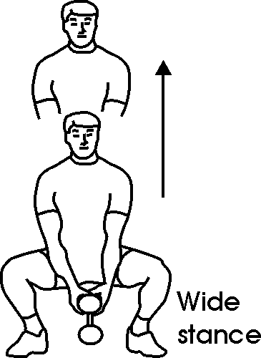 |  |  | 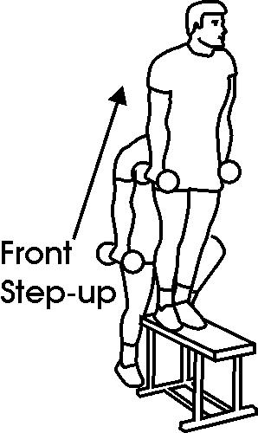 |  |  |  |  |  | 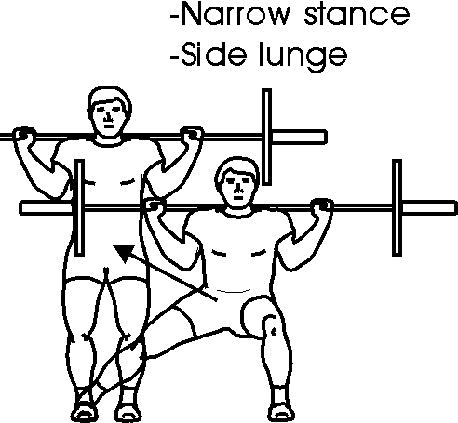 |  |  |  |  | 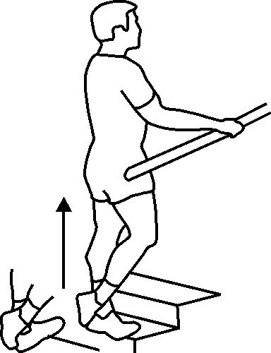 |  |  |  |  |  | 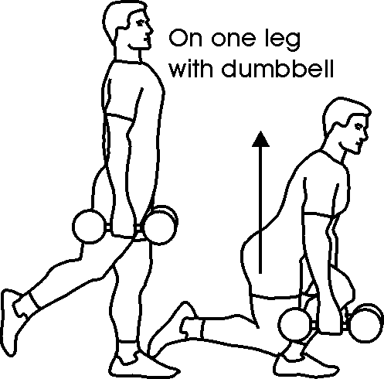

UPPER BODY EXERCISES
 | Week 1 |  | 2 |  | 3 |  | 4 |  | 5 |  | 6 |  | 7 |  | 8 |  | 9 |  | 10
Exercise | Reps  15 | Sets  3 | Reps  15 | Sets  3 | Reps  15 | Sets  3 | Reps  10 | Sets  3 | Reps  10 | Sets  3 | Reps  8 | Sets  3 | Reps  8 | Sets  3 | Reps  6 | Sets  3 | Reps  6 | Sets  3 | Reps  6 | Sets  3
PUSH UPS | Reps | Sets
Dips (off chair) | Reps | Sets
Lateral hand walk | Reps | Sets
Side planks | Reps | Sets
UPPER BODY EXERCISES
Push Ups | Dips | Lateral WALKS | Side Planks
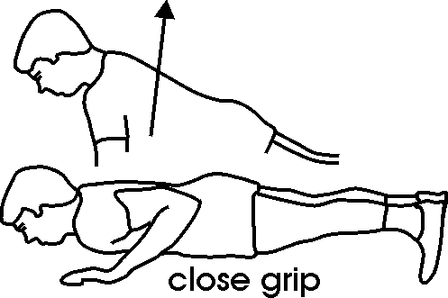 | 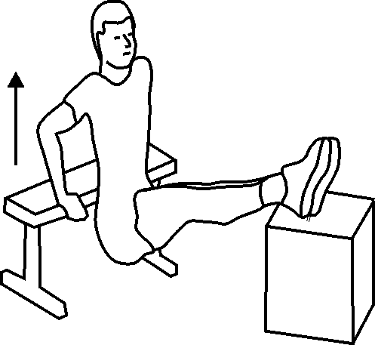 | 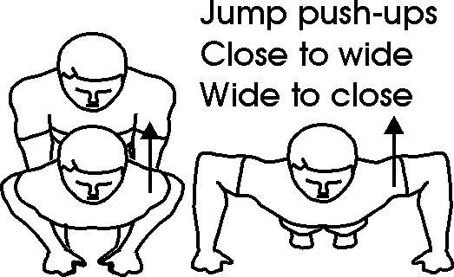 | 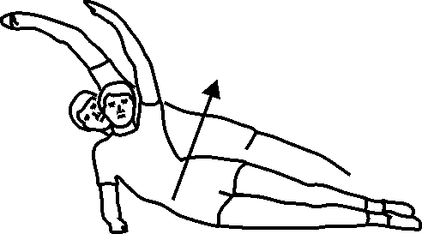

CORE EXCERISES
 | Week 1 |  | 2 |  | 3 |  | 4 |  | 5 |  | 6 |  | 7 |  | 8 |  | 9 |  | 10
Exercise | Reps  15 | Sets  3 | Reps  15 | Sets  3 | Reps  15 | Sets  3 | Reps  10 | Sets  3 | Reps  10 | Sets  3 | Reps  8 | Sets  3 | Reps  8 | Sets  3 | Reps  6 | Sets  3 | Reps  6 | Sets  3 | Reps  6 | Sets  3
Lower back extensions | Reps | Sets
AB Curls | Reps | Sets
Side leg Lifts | Reps | Sets
Reverse Abs | Reps | Sets
Rotational leg Drops | Reps | Sets
Core Exercises
Lower Back Bridge | AB curls | Side leg raise | Reserve Abs | Rotational leg drops
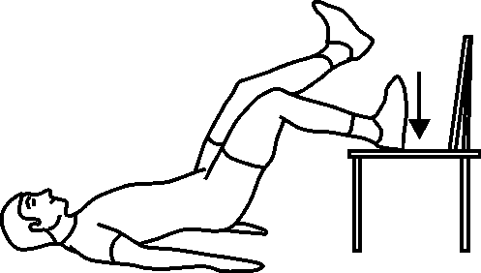 | 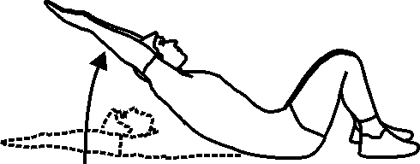 | 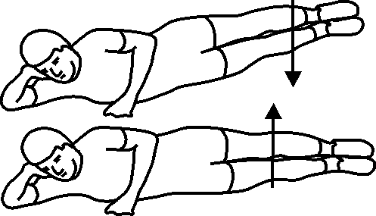 | 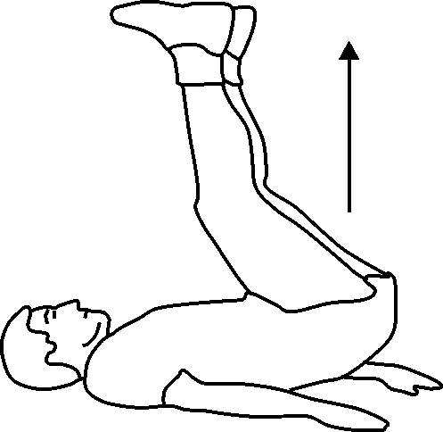 | 